10/15/21,
Revised: 10/18/22 (Property lot lines)

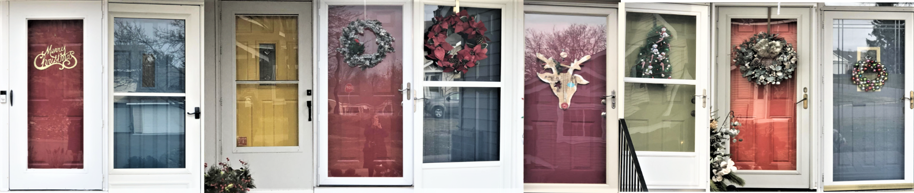

CARVER LAKE MEADOWS
Homeowners Associations

Rules & Regulations, 7th Revision

October 15, 2021
Revised 10/18/22 to include Property Lot Lines

This document contains important information for all homeowners and tenants. The Board of Directors desires to provide information and guidelines that protect the value and interest of all owners in Carver Lake Meadows Homeowners Association.

THESE RULES AND REGULATIONS ARE EFFECTIVE OCTOBER 15, 2021

TABLE OF CONTENTS

Welcome to Carver Lake Meadows!
Governing Documents …………………………………………………………………………………………………………3
Board of Directors …………………………………………………………………………………………………… …...3
Property Use ………………………………………………………………………………………………… ……...4
Routine Building Maintenance
Your Financial Responsibilities as a Homeowner ………….…………………………………...4-5
Architectural Responsibility Guidelines at-a-glance
Architectural Modifications and/or Remodeling
Contracted Services ………………………………………………………………...……………...6-7
Garbage Collection
Snow Removal
Grounds and Landscaping
Grounds and Landscape Responsibilities At-A-Glance
Residential Guidelines …………………………………………………………………………………. 7-8
Unit Lot Boundaries and Private Use (added 10/18/22)
Barbecues & grills
Storage
Pets
Exterior Structures, Decorations and Signs
Vehicles
Winterizing Your Unit
Appendix A – Carver Lake Meadows Contact Information
Management
Board of Directors
Contracted Services
Appendix B – Enforcement Procedures for Rules Violations
Appendix C: Homeowner Leasing/Selling Policy & Procedures
Leasing Your Unit
Selling Your Unit
Appendix D – Standards and Expectations of Vendor work at Association Property
Appendix E - Property Plat Map and MN State Statute (added 10/18/22)

Welcome to Carver Lake Meadows!
Carver Lake Meadows Homeowners Association (CLMHOA) is a residential community. It is the purpose of these Rules and Regulations to provide reasonable guidelines relating to the operation and upkeep of Carver Lake Meadows in order to provide the highest quality of residential townhome living for the present and future.

All homeowners become members of the Association upon purchase of their home at Carver Lake Meadows. Homeowners are responsible for their property. Association members agree to abide by pre-established guidelines in the governing documents.

Each homeowner shall comply with all applicable laws, ordinances and regulations of the City of Woodbury and of the governing documents of the CLMHOA. CLM Rules and Regulations may be more restrictive in some cases.

Governing Documents
A full copy of all this documentation was provided to you at the time you purchased your home. They are also available on the CLMHOA.com website. They consist of:
- Articles of Incorporation: ‘short documents that set the name of the HOA, assert that it is a nonprofit mutual-benefit corporation and identify its initial agent.’
- Declarations of Covenants, Conditions and Restrictions: ‘a recorded document setting forth the majority of the powers, rights, and responsibilities of the association and its members.’
- By Laws: ‘describe the procedures and mechanics of homeowners association management and decision-making.’
- Rules and Regulations: ‘the standing operating rules of the Association are provided in more detail than the overarching by-laws. The Board may revise these without a homeowner vote. The By-laws supersede the Rules and Regulations.‘
These documents may be amended periodically. This version supersedes any previous versions of the Rules and Regulations.

Board of Directors
The Board of Directors, elected by the Homeowners of the CLMHOA, is charged with the enforcement of these Rules and Regulations. This enforcement will be within the bounds of, and with the authority given to the Association by the Governing Documents of the CLMHOA. Unless otherwise noted in these Rules and Regulations, terms utilized shall be as defined in the Governing Documents.
The Board of Directors may choose to enlist the services of a property management company to assist in managing the Association. Their responsibilities could include implementing decisions of the Board, overseeing operational policies, and fiscal and administrative services. For purposes of this document, the term “Management” will be used to refer to the party responsible for enforcing CLMHOA policies.
For Management Contact Information | Refer to Appendix A

Property Use
Other than personal office space, commercial business may not be operated out of the home.

Routine Building Maintenance
It is the obligation and responsibility of Homeowners to maintain their unit according to the City of Woodbury fire and safety codes and other regulations, as well as HOA community standards of appearance and material. All financial responsibility rests with the Homeowners, either directly or shared through the Association Dues. Any exterior maintenance or modification must be submitted on the Architectural Review Form and approved prior to implementation.
A link to City of Woodbury ordinances can be found here: (http:www.woodburymn.gov)
** The City of Woodbury is responsible for the HOA street light maintenance, main water and sewer lines (from main city street to curb in front of the unit) and maintenance of the ponds near Lake Terrace East.
** Water and sewer lines from curb to unit are the Homeowner’s responsibility, and may be covered by an HO6 policy addendum.

Your Financial Responsibilities as a Homeowner
As outlined in Section 8 of the Amended and Restated ByLaws, each owner is responsible for monthly association dues, special assessments and acquiring an HO6 insurance policy (refer to Declaration, Section 11 for specific insurance responsibilities). The chart below offers a quick view of building maintenance responsibility. This document is available on the website..

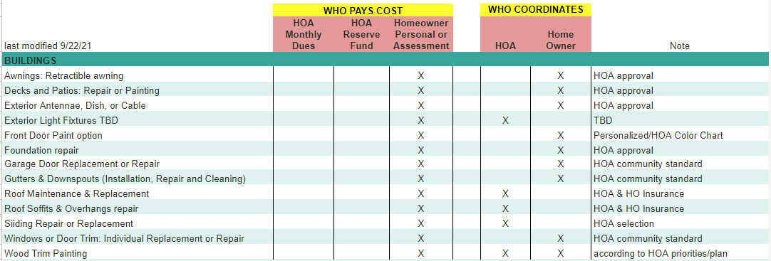
Architectural Responsibility Guidelines at-a-glance

Architectural Modifications and/or Remodeling
- All exterior repairs and maintenance must be of similar visual appearance. Material selection must be approved through the Architectural Review Process. This form must be approved prior to beginning work. Failure to obtain prior approval may result in having to replace new items at Homeowner expense.
- Interior structural modifications must have city permits.
- Prior to any proposed construction or remodeling that affects exterior walls or roof, Homeowners must complete and submit an Architectural Review Form to Management for approval.
- Exterior fixtures:
  - Attachments to exterior siding or roof are not permitted without prior approval of the Board (complete Architectural Review Form).
  - Antennas and satellite dishes may not be attached to the building or roof in any way. They may be attached to patio posts or free-standing posts may be placed immediately at the edge of Homeowner’s patio, but may not impede lawnmowers. Installations violating this rule will be removed at the owner’s expense.
- Roof access to CLMHOA units is prohibited except by Management authorized personnel.
- If an owner or contractor needs access to adjoining properties, Management must be notified ahead of time, except in case of an immediate emergency. Neighbors affected must be directly notified by the homeowner. Any resulting property damage is the responsibility of the initiating homeowner.
- All remodel and repair work must be done between the hours of 8am and 7pm each day.

Contracted Services
Garbage collection, snow removal, landscaping, and select grounds maintenance services are contracted through the Association. The following grid summarizes those services:

Garbage Collection
- Trash and recycling service is provided weekly. The vendor will provide residents with containers. Containers may be placed at curbside the day before scheduled pick-up and returned to the garage by the evening of pick-up day.
- Containers must be stored in the garage.
- The vendor will pick-up larger items by homeowner arrangement at the Homeowner’s expense.
- To arrange special services, call Tennis Sanitation by 9:00 am Friday to schedule your special request for the upcoming Wednesday Garbage/Recycle service. Special services are to be billed directly to the Homeowner.

Snow Removal
- When plowable snow of 1 1/2 inches or more is forecast, no street parking is permitted and arrangements must be made to move any vehicle parked on driveways.
- Driveways with parked cars will not be plowed and the resident will be responsible for clearing their driveway within 24 hours. If an adjoining driveway cannot be plowed due to the parked vehicle, the owner of the obstructing vehicle will be responsible for the cost of additional snow removal service if required. Repeat violators are subject to Association fines and towing at owner's expense.
- Members are responsible for removing snow of less than 1-1/2 inches.
- The vendor will provide salt containers at the mailbox locations for homeowner use.

Grounds and Landscaping
- The Association provides lawn services for the entire property.
- However, Homeowners are responsible for watering their lawns and front-beds and for weeding and maintaining the side and back borders of their unit.
- Any lawn or tree replacement cost necessitated by neglect may be assessed to the Homeowner.
- Any alternative shrubs or plants must be approved by the Board via an Architectural Review Form. Any modifications to the landscape must be pre-approved by the Board using the Architectural Review Form.

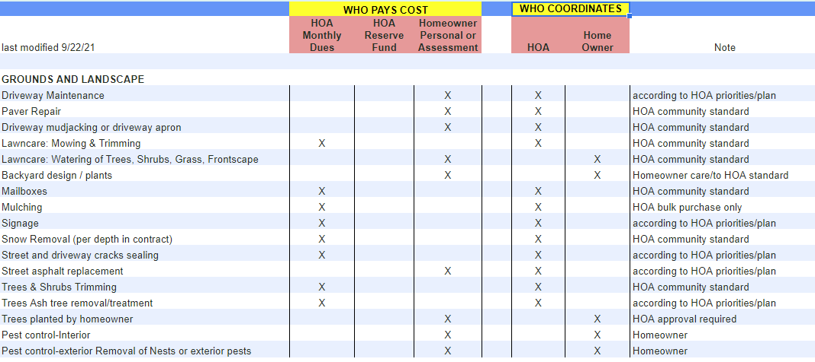
Grounds and Landscape Responsibilities At-A-Glance

Residential Guidelines
Residents must follow all Federal, State, and City Laws and Regulations. In addition, the following guidelines have been approved by the Board in order to preserve the value of our community.

Unit Lot Lines and Private Use Yards (added 10/18/22)
- According to the county plat maps, and your property title, each unit has designated yard space that belongs to the individual unit. Our lawns are not common space as in some townhome associations. Please respect your neighbors and keep guests, children, and pets off of the private yards of other residents. Please see Appendix E for County Plat Maps and State Statute on Unit Boundaries.

Barbecues & grills
- Stationary grills using gas, charcoal or pellets are allowed on decks, patios and driveways (but note that any use of igniting fluids requires that the grill to be placed 15 feet from the building (side or above).

Fire PIts
- City ordinances provide specific guidelines which you must follow: Recreational Fires https://www.woodburymn.gov/departments/fire/recreational_fires.php which is part of Chapter 8 of the Municiple Code: FIRE PREVENTION AND PROTECTION).

Property Storage & Maintenance
- Homeowners are responsible for keeping their lot free of clutter. All toys and yard equipment must be stored in their garage.
- No storage is allowed on or under decks or patios or within other exterior spaces with the exception of patio furniture and grill equipment on the patio/deck.
- No dumping or abandoning of personal items on or around the property in common areas.

Pets
In addition to complying with the Woodbury Animal Control Ordinance, there is a limit of two dogs or cats or combination thereof per unit. All dogs must be leashed by their owner at all times when outside the unit. Tethering outside of the home is allowed under close supervision. No kennels or dog houses are permitted. All pet waste must be picked up daily as per City of Woodbury ordinance. Any lawn or landscape damage is the responsibility of the owner.

Exterior Structures, Decorations and Signs
- No structure of any kind may be placed or installed on the lawn areas, including playground equipment, posts, lawn ornaments, birdfeeders, birdbaths, etc that would impede landscape maintenance. Exterior decorations are allowed in moderation.
- No yard or window signs of any kind are allowed with the exception of “For Sale” signs (not more than five square feet) may be displayed next to the unit only and not placed via post in any grounds. Posts and large realtor signs are prohibited anywhere on the property.
- Small security system/video surveillance notification signs are permitted.

Vehicles
  - Parking
    - Homeowners and Renters are limited to four parking spaces per unit including two garage spaces and two driveway spaces immediately in front of their garage.
    - Homeowners and Renters in multi-unit driveways (4-6 units) need to take care to not block their neighbor’s driveway area.
    - Guest parking is limited to the resident’s driveway or on a short-term basis on the side of the street opposite the mailboxes (but restricted to 48 hours in a 30 day period).
    - No parking is allowed on the mailbox side of the street. Signs are posted “No Parking Fire Lane” as per City of Woodbury regulations.
  - Service vehicles or equipment should take every precaution to not damage property. Any property damage incurred will be charged to the initiating unit owner. Communicate with your neighbor when service vehicles are expected.
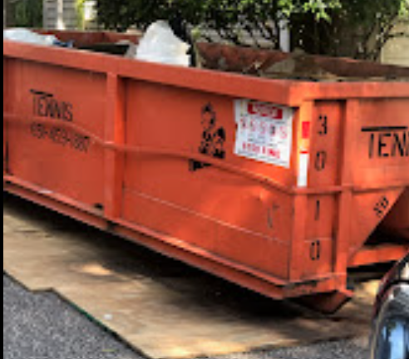
  - Large metal dumpsters (used during renovations or moving) must be pre-approved by the Board and have a timeframe designated for removal. Vendor should take every precaution to not damage property. Any property damage incurred will be charged to the unit owner.
  - Other vehicle guidelines
    - No inoperative or unlicensed vehicle may be stored on driveway
    - No vehicle repair work of any sort may be performed on driveways, streets, or any other areas outside of the garage.
    - No motorhomes, recreational vehicles, trailers, boats, or other operational equipment, farm machinery or sports equipment shall be parked or stored in driveways or on the street.
    - Mopeds/motorcycles must be parked in the Homeowner's garage to prevent kickstand damage to asphalt.
**Failure to follow these regulations can result in the removal of unauthorized vehicles at owner's expense.

Garage Sales
Please be respectful of your neighbors when planning a garage sale using the following considerations:
- Homeowners conducting a garage sale will be responsible for implementing and directing the following parking restrictions:
Devonshire shoppers will be restricted to parking on Devonshire Drive.
Lake Terrace East shoppers will be required to observe Fire Lane and No Parking zones with a specific plan for turn-around.
- Garage sales can be held only on Saturdays between the hours of 8am to 5pm.
- Any trash or refuse must be removed by the owner immediately following the sale.
- Any signage must be removed immediately following the sale

Winterizing Your Unit
Homeowners are responsible for shutting off water to outside faucets and draining the pipes before temperatures fall below freezing. Hoses should be stored in the garage during winter months. (Failure to properly drain outside faucets resulting in burst pipes may void the HOA insurance policy coverage and damage and repairs are the Homeowner expense.)

Appendix A – Carver Lake Meadows Contact Information

Management:
- Management is shared between CLMHOA Board of Directors and HOA-Assist.
- The CLMHOA.COM website is your primary source of information and communication for the association.
- HOA-Assist is our financial manager. Homeowners must login to their personal HOA-Assist (Appfolio) account to manage payment of dues and assessments and to access their account statements. Find the link at CLMHOA.COM.

Contacting the Association for various items:
- General questions or concerns can be directed to the board using the CONTACT US form on the website.
- Document request: Association documents for your realtor or mortgage broker can be requested from info@hoa-assist.com.

Board of Directors:
Please see the website: clmhoa.com for the current Board member names.
Board members can be directly emailed through their Board Position Email address.
President@clmhoa.com
Secretary@clmhoa.com
Treasurer@clmhoa.com
Grounds@clmhoa.com
Buildings@clmhoa.com

Contracted Services:
- Tennis Sanitation - (651) 459-1887 (hours - 7:00am to 4:30pm)
If special services are required, call Tennis Sanitation by 9:00 am Friday to schedule your special request for the upcoming Wednesday Garbage/Recycle service. Special services are to be billed directly to the Homeowner.
Email support : support@tennissanitation.com
Web site: Homepage - Tennis Sanitation

***Please do not contact vendors directly for association contracted concerns.

Appendix B – Enforcement Procedures for Rules Violations
Complaints regarding Rules violations must be submitted in writing to the Board. Anonymous complaints will not be accepted. The Board will keep complaints confidential, as far as is practical. The Rules and Regulations shall preside over Carver Lake Meadows in all areas that do not conflict with or contradict the Association’s governing documents. In any such instance, the Association’s governing documents shall take precedence over the Rules and Regulations.

Action on Complaints
Complaints will be reviewed by the Board at its next scheduled meeting. Any recommended action will take place at the regularly scheduled Board meeting, unless an issue of safety or security is in question. The owner may request a meeting with the Board.

Authority to Establish and Assess Fines
The Board has the authority to establish and levy fines for rule infractions against the offending owner’s unit, to be collected in the same manner as other Association assessments.

Appendix C: Homeowner Leasing/Selling Policies and Procedures

Leasing Your Unit
Homeowners intending to lease their unit MUST INFORM THE BOARD by written notice at least forty-five (45) days prior to the commencement of the lease and closely follow the procedures set forth below.

Rental Policy:
  - Rental is prohibited for transient or hotel purposes (VRBO, etc.)
  - Lease/Rental is prohibited for a period of less than twelve (12) consecutive months.
  - Units must be leased in their entirety – no part of the unit or rooms may be separately leased.
  - Homeowners are responsible for providing their tenants with a copy of association rules and regulations. Homeowners are ultimately responsible for tenant infractions.
  - The lease agreement shall (must) include the following language:
"This lease agreement is subject to the Association’s governing documents and tenants are subordinate and subject to the provisions of these documents. A tenant violation of any of the governing documents constitutes a violation of the lease. Failure of the tenant to comply with the terms of Association documents and Rules & Regulations violates the lease agreement and shall be a default under the lease enforceable by the Association as well as the landlord.
  - Provide Management with copies of the following prior to commencement of any lease (new and/or renewed lease):
- Lease Agreement
- Name of the Lessee and all occupants of the unit
- Include all contact information: telephone numbers, and email addresses, and vehicle license plate number
- Verification of background check performed on lessee, and all occupants
- Verification that the owner has provided the lessee with CARVER LAKE MEADOWS Governing Documents and Rules & Regulations.

- The Owner must continue to DIRECTLY pay Association dues. Dues may not be paid to the Association by the tenant. All communication will be conducted between the Association and the Owner. The Tenant is subject to all HOA rules and regulations. The owner is responsible for ensuring that the lessee complies with those documents and all Rules and Regulations of the Association. Violations of the lease agreement will require the lease to be terminated.

Selling Your Unit
Any Homeowner considering the sale of their unit must inform the Board of their intent to sell and comply with the regulations stated in Appendix C.

Management shall furnish requested documents to owner and/or authorized agent within seven (7) days after a written request and payment of applicable fee(s)

Authorized agents and/or owners shall provide updated Governing Documents and Rules & Regulations to prospective buyer(s), including, but not limited to:
- Declarations and Amendments thereto
- By-Laws
- Articles of Incorporation
- Rules and Regulations

Appendix D – Standards and Expectations of Vendor work at
Association Property

General Guidelines
Carver Lake Meadows takes pride in maintaining Association property and in working with vendors that exemplify these standards. The procedural items listed below are the expected standards required of all vendors doing work at the CLM Association.
Refer to Responsibility Guidelines At a Glance.

CLM HOA contracted work (ie roofs, siding, roads, grounds, etc):
- Management will coordinate with vendors and schedule work to be completed.
- Homeowners will be notified of the work schedule and personal preparations required.
- Homeowners will be assessed as per governing documents.
- All Homeowner communication should be through the Board. Homeowners should not communicate with CLM contracted vendors.

Home Owner contracted work:
- Refer to the Vendor Recommendation link on CLMHOA.COM for potential vendors for work to be done. You are not required to hire from this list, but they have been used by other CLM homeowners.
- Homeowners will schedule work directly with vendor
- Vendors are to be licensed (as required), professionally insured.
- Owners must submit an architectural request form (with photos) for desired work to be completed. Vendors will invoice homeowners directly.
- Vendors must make proper preparations to avoid property damage. Owners will be responsible for the repair of any vendor damage.

Appendix E – County Plat Maps and State Statute on Unit Boundaries
(added 10/18/22)
- According to the county plat maps, and your property title, each unit has designated yard space that belongs to the individual unit. Our lawns are not common space as in some townhome associations. Please respect your neighbors and keep guests, children, and pets off of the private yards of other residents. If contractors need to cross another lawn to access the yard or exterior of a middle unit, neighbors should be notified, and contractors should be informed to be respectful of other unit’s privacy.

County Plat Map
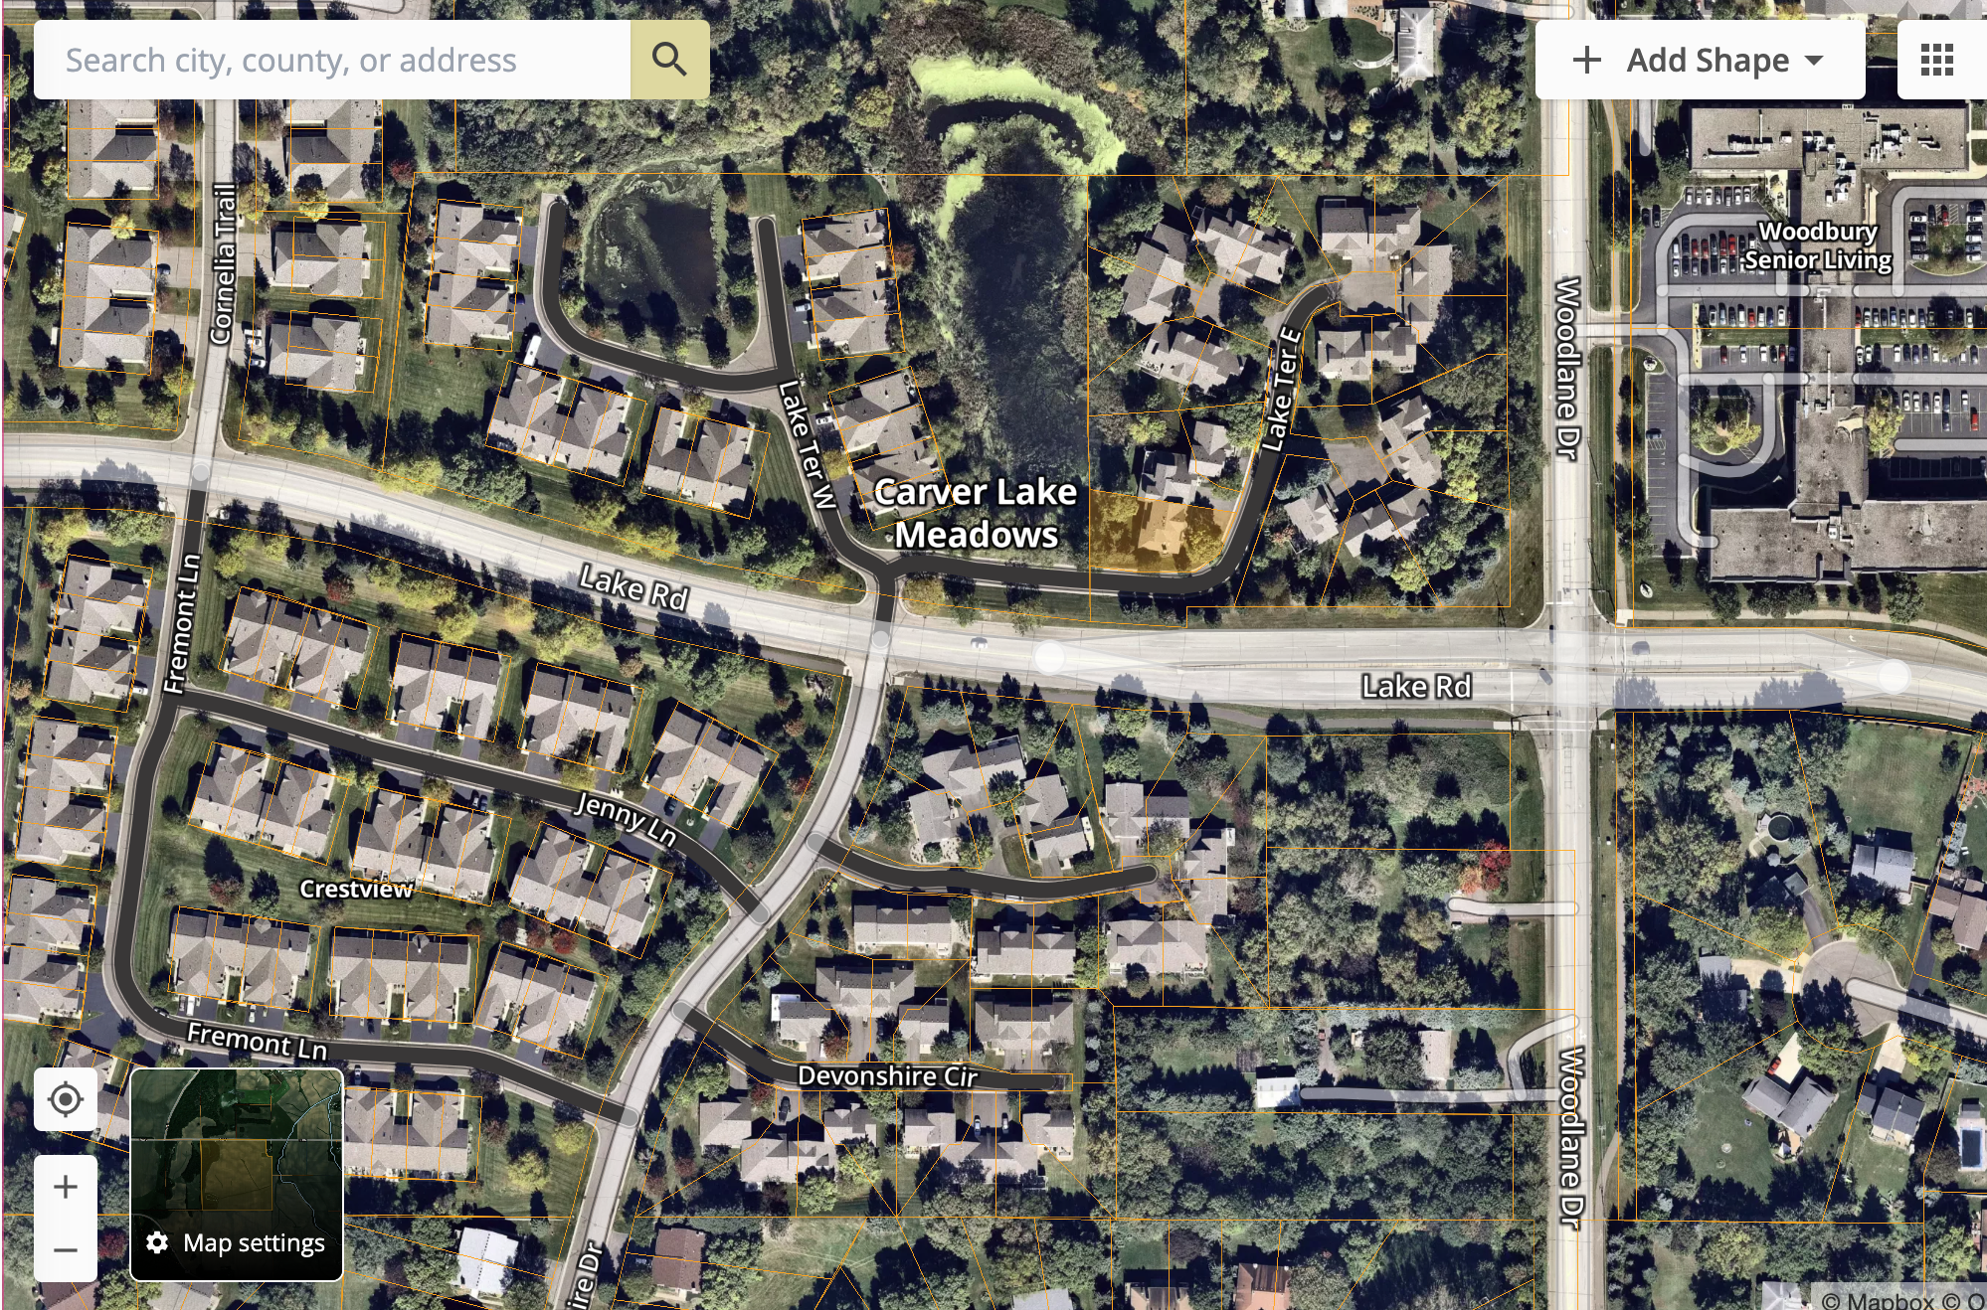
Orange lines are property lines. Note the difference between Carver Lake Meadows lot lines that extend beyond the units, and the Crestview Townhomes that have “0 Lot Lines” and do not extend past the building and driveway.

MN Statutes on Unit Boundaries:
